Skewness in Statistics (Machine Learning Mathematics)
What is Skewness?
Skewness measures the asymmetry of a data distribution.
- If data is perfectly symmetric → skewness = 0 (Zero Skewness)
- If tail is longer on right side → positive skew (Right Skewed)
- If tail is longer on left side → negative skew (Left Skewed)
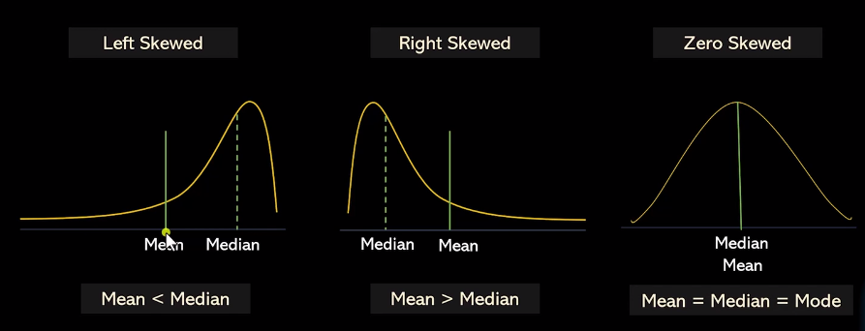

1. Symmetric Distribution (Zero Skewness)
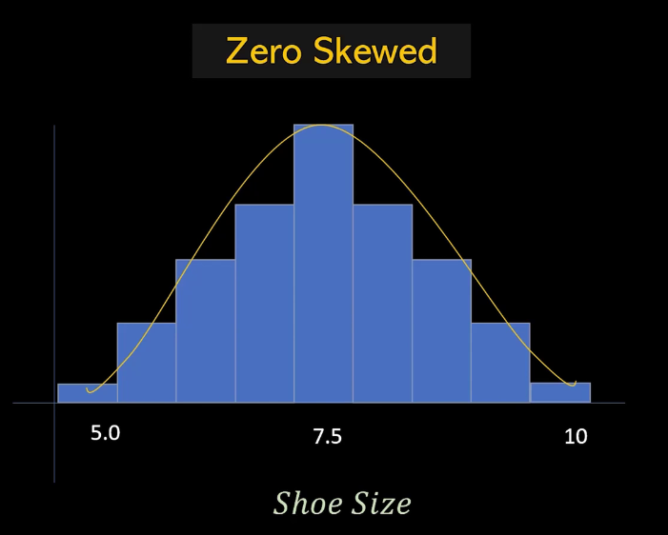
In symmetric data:
- Mean ≈ Median ≈ Mode
- Left and right sides are balanced
- Data evenly spread around the mean, forming a symmetrical shape.
- Ex
  - Shoe Sizes

2. Positive Skewness (Right Skewed)

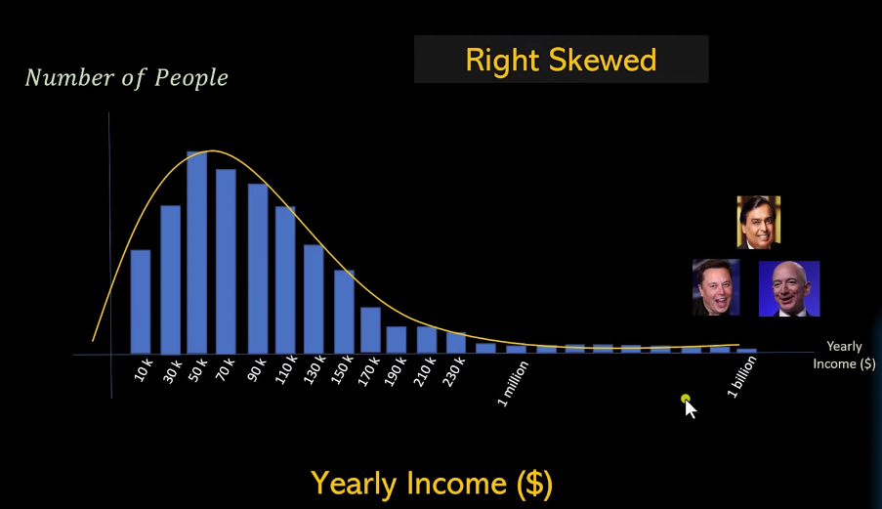
- Mean > Median
- Tail is longer on the right side.
- Most data on the left with a few high values extending right
- Ex
  - Yearly Income
  - Hospitalization Days
  - Advertising Budget

3. Negative Skewness (Left Skewed)
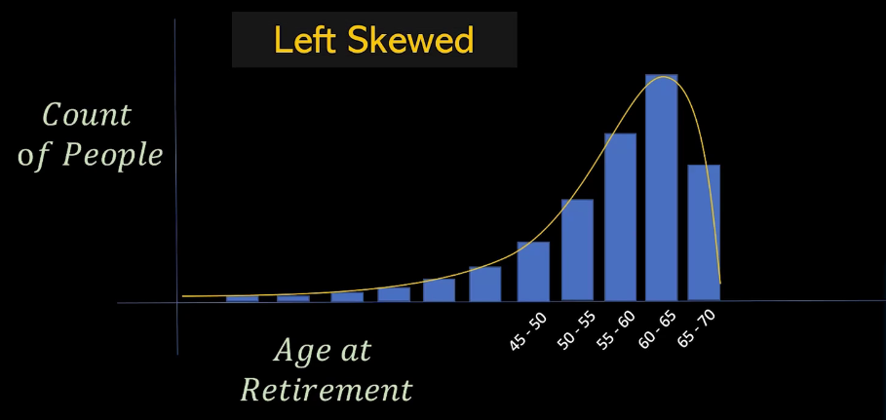
- Median > Mean
- Tail is longer on the left side.
- Most data on the right with a few low values extending left.
- Ex
  - Age of Retirement
  - Lifespan of TV,

